FUNERAL SERVICES INC. PRICE LIST

Effective as of November 23rd, 2022
1666 King Street East, Cambridge, ON N3H 3R7
Phone (519) 650 - 1565
Fax (519) 650 -1595
License # FE-1388

E-mail: tranquilitycambridge@gmail.com

Chris Silverthorne – Owner and Funeral Director
David Taylor – Managing Funeral Director

H.S.T (13%) applicable to all services and merchandise

Full Service Funeral (One Day Service)
A full service funeral option that includes: Staff for visitation (2 hour visitation period with a 1 hour service to follow at chapel or church) listed below are the itemized charges. Please note that a rental fee for facilities may be in addition to this option. Facility charges will be handled as a disbursement at cost. Please ask your Funeral Director for location options. Other disbursements may be additional.
Professional & Staff Services:

Co-ordinating activities, rites, ceremonies $ 950
Documentation – permits, forms, etc $ 375
Transport of remains – Initial (75 km) $ 125
Basic preparation of remains $ 200
Embalming $ 495
Facilities for preparation, embalming, shelter $ 100
Staff services for visitation/ceremony (4 hrs) $ 1,295
Transport of remains to cemetery – crematorium $ 125
Total $3,665

Full Service Funeral (Two Day Service)
A full service funeral option, that includes: Staff for visitation (up to 4 hours of visitation with a 1 hour service the following day at a chapel or church) consulting, planning, arranging, administration, embalming, other preparation, shelter, transfer to funeral home and death certificates. Please note that a rental fee for facilities may be in addition to this option. Facility charges will be handled as a disbursement at cost. Please ask your Funeral Director for location options. Other disbursements may be additional.

Professional & Staff Services:

Co-ordinating activities, rites, ceremonies $ 950
Documentation – permits, forms, etc $ 375
Transport of remains – Initial (75 km) $ 125
Basic preparation of remains $ 200
Embalming $ 495
Facilities for preparation, embalming, shelter $ 100
Staff services for visitation/ceremony (6 hrs) $ 1,945
Transport of remains to cemetery/crematorium $ 125
Total $4,315

Shipping Service
This service is for shipment of human remains to another province or out of the country. This does not include visitation or funeral services before shipment, Airfare, consulate fees, and any other fees or disbursements in regards to shipment of the remains.

Professional & Staff Services:
Co-ordinating activities and shipment | $ 950
Documentation – permits, forms, etc | $ 700
Transport of remains – Initial (75 km) | $ 125
Basic preparation of remains | $ 200
Embalming | $ 495
Facilities for preparation, embalming, shelter | $ 100
Transport of remains to Airport | $ 125
Staff for obtaining certified death Certificates | $ 200  Total $2,895

Direct Cremation/Burial
A direct burial or cremation includes all necessary documentation, staffing and vehicles. There are no funeral services or religious services included in this package. Disbursements may be additional.

Professional & Staff Services:

Co-ordinating activities $ 500
Documentation – permits, forms, etc. $ 300
Transport remains (Initial 75km) $ 150
Facilities to shelter remains $ 150
Total $1100

Memorial Service/Graveside Service
This package includes all necessary documentation, staffing of memorial service or graveside service to take place at a chapel, church or cemetery. Disbursements may be additional

Professional & Staff Services:
Co-ordinating activities, rites, ceremonies |  | $ 500
Documentation, permits, forms, etc |  | $ 300
Transport remains (Initial 75km) |  | $ 125
Basic preparation of remains |  | $ 200
Facilities to shelter remains |  | $ 100
Staff services for ceremony |  | $ 600
Transport of remains to cemetery/crematorium |  | $ 125
 | Total | $1950

Casket Selection
(Please, note a wider selection of caskets is available upon request)

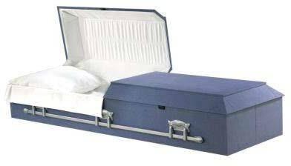

Toledo Price: $900
Model: 90-55-01
Manufacturer: Victoriaville Exterior Size: 79″x25″x16″
Exterior Material/Colour: Blue cloth and Fiberboard
Interior Colour/Material: White Silk Thickness: ½”
Cremation or Burial

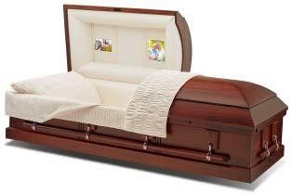
Clifton Price: $1950 Model: 263630
Manufacturer: Batesville Exterior Size: 82.5″x28.25″x23″
Exterior Material/Colour: Wood/Dark Brown Interior Colour/Material: Rosetan Crepe (Optional Lace overlay)
Thickness: ½” Cremation or Burial

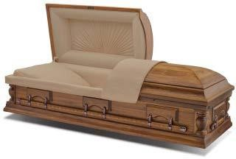
Bailey
Price: $2475
Model: 263781 Manufacturer: Batesville
Exterior Size: 82.5″x28.25″x23″ Exterior Material/Colour: Hardwood, Pecan stain
Interior Colour/Material: Champagne Thickness: ½”
Cremation or Burial
Puma Price: $1700
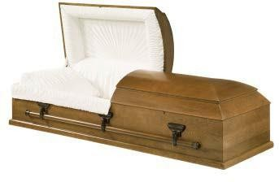
Model: 52-652-00
Manufacturer: Victoriaville Exterior Size: 82″x27″x20.25″
Exterior Material/Colour: Hardwood select, Brown stain
Interior Colour/Material: Rosetan crepe Thickness: ½”
Cremation or Burial

Dryden Price: $2050 Model: 274158
Manufacturer: Batesville Exterior Size: 80’x25’’x19’
Exterior Material/Colour: Hardwood Interior Colour/Material: Rosetan crepe Thickness: ½”
Cremation or Burial

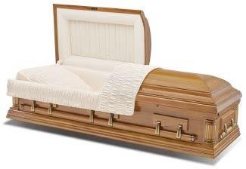
Trenton Price: $2750 Model: 205161
Manufacturer: Batesville Exterior Size: 82.5″x28.25″x23″ Exterior Material/Colour: Wood Light stain
Interior Colour/Material: Rosetan Crepe Thickness: ½”
Cremation or Burial
Lynx
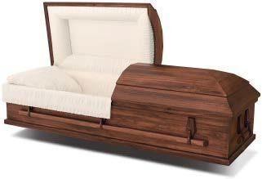
Price: $1800
Model: 262858 Manufacturer: Batesville Exterior Size: 82″x29″x 23″
Exterior Material/Colour: Veneer, Matt Brown
Interior Colour/Material: Rosetan Crepe cloth Thickness: ½”
Cremation or Burial
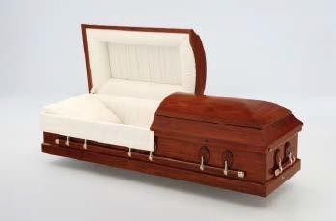
Gurnet Price: $2150 Model: 217987
Manufacturer: Batesville Exterior Size: 82.5″x28.25″x23″
Exterior Material/Colour: Hardwood select, Cherry stain
Interior Colour/Material: Rosetan crepe Thickness: ½”
Available in full couch
Cremation or Burial

Eleanor Oak Price: $2900 Model:195908
Manufacturer: Batesville
Exterior Size: 78.28″x28.25″x23″ Exterior Material/Colour: Oak Interior Colour/Material: Pink Crepe Thickness: ½”
Cremation or Burial

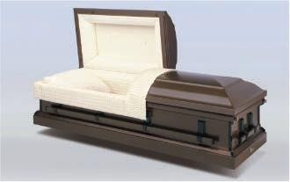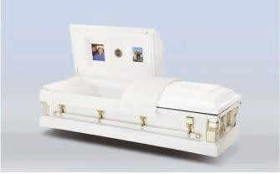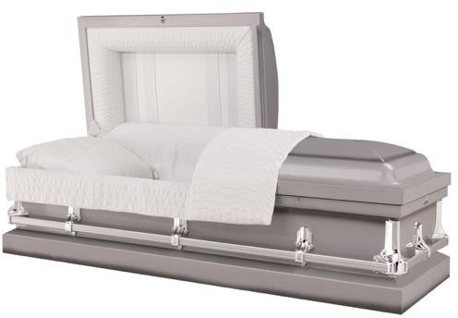

Earthtone (20ga Steel) Price: $1825
Model: 148028 Manufacturer: Batesville Exterior
Size: L83xW28xH24
Exterior Material/Colour: earthtone, Metal Interior Colour/Material: Rosetan crepe Thickness: ½”
Burial Only
Ivory (20ga Steel) Price: $1700 Manufacturer: Batesville
Exterior Size: L83xW28xH24
Exterior Material/Colour: White&gold, Metal Interior Colour/Material: Ivory crepe Thickness: ½”
Burial Only
Bailey Silver (20ga Steel) Price: $1900 Model:MR260-00110
Manufacturer: Victoriaville Size: L83.75xW28.75xH23
Exterior Material/Colour: Non Gasketed Metal/Silver finish
Interior Material/Colour: Silver Grey Crepe Burial Only

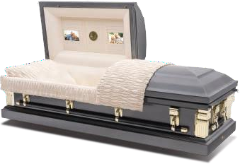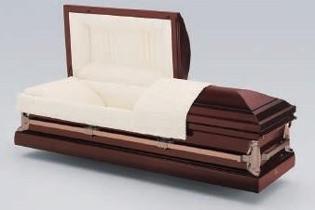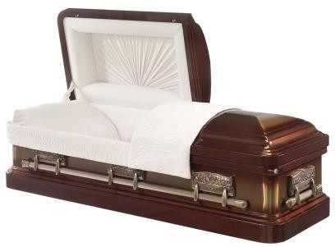

Heirloom Pewter (20ga Steel) Price: $1900
Model: 242475 Manufacturer: Batesville Exterior Size: L83xW28xH24
Exterior Material/Colour: Grey Metal Interior Colour/Material: Rosetan Crepe Thickness: ½”
Burial Only
Sunglow (20ga Steel) Price: $2200
Model: 148073 Manufacturer: Batesville Exterior Size: L83xW28xH24
Exterior Material/Colour: Copper/,Metal Interior Colour/Material: Rosetan Crepe Thickness: ½”
Burial Only
Cognac Jewel (18gaSteel) Price: $2950
Model: MR250-00098
Manufacturer: Victoriaville Exterior Size:L83.5xW29xH22.75
Exterior Material/Colour: Metal/ Cognac Brushed Brown
Interior Material/Colour: Beige Velvet Burial Only

Century Concrete Burial Vaults
(Standard dimensions, oversized available if required)

Intermediate Crypt | $1300
Monarch Vault | $1500
Monticello Vault | $1900
Venetian | $2400

Additional Services

Funeral Coach (3 hour use) $ 550

Coach overtime (charged per hour) $ 100

Clergy Car / Lead Car (3 hour use) $ 475

Flower Vehicle $ 125

7 Passenger Limousine (3 hour use) $ 650

Limousine Overtime (charged per hour) $ 125

Memorial Cards (Folded) $ 2 Each

Weekend Service Surcharge $ 200

Register Book $ 40

Priority Cremation/Burial (Within 24 hours of death) $ 250

Pallbearer Assistance (per person) $180

Mileage Fee (charged after the first 75 km) $ 3/km

Second Attendant for Transfer (Residence) $ 250

Staff for Post Funeral Reception $ 200

Staff for obtaining certified death certificates $ 200

Storage Fee per day after four (4) days $ 40

Air Tray $ 600

1/2 Glass Sealer $ 1000

Delivery of Cremated Remains (within 50 km) $ 75

Shipment of cremated remains within Ontario $ 125

Shipment of cremated remains within Canada $ 200

Infectious Disease Embalming Kit $ 275

Handling of Infectious Remains $ 175

Cosmetic Application (No embalming) $ 200

Body containment pouch $ 125

Scattering of Cremated Remains $200

Staff for obtaining documentation from Consulate $ 200

Disbursements (NO H.S.T)

Items arranged and paid for by us on your behalf. You are required to pay for these items at the time the contract is entered into. The following is a list of items that are often identified as disbursements.

Municipal death registration fee | $35
Coroner’s Cremation Certificate | $75
Coroner’s Out of Province Certificate | $75
Clergy Honorarium | $300

Explanation of services
- Co-ordinating activities, rites, ceremonies – Professional consultation with licensed staff, including but not limited to: expert advice on options to meet your needs, co-ordination of all activities, rites and ceremonies, before, during and after they have been provided, including services and supplies provided by us, as well as those provided by third party suppliers, such as flowers and catering.
- Documentation – Completion and filing of all documents necessary to carry out the services and supplies
requested, including but not limited to death registration, burial permit, coroners’ certificate for cremation, documentation necessary to ship remains out of the country, provision of 12 proof of death certificates from Tranquility. Please note: Our proof of death certificates are usually accepted for most estate settlement purposes, but sometimes a provincial “Certified Death Certificate”, will be necessary and is available from the Office of the Registrar General, or online at www.ontario.ca
- Transport remains – Transportation of remains from one place to another, for example the hospital to Tranquility, or Tranquility to the crematorium or cemetery. An additional fee of $250 may be charged if the use of two staff members is required for the initial removal from the place of death.
- Basic preparation of remains – (requires Facilities for preparation/embalming/shelter) The preparation
of the body for placement into the casket, including bathing, dressing and the setting of facial features for identification or viewing without embalming.
- Embalming of remains – (In addition to basic preparation of remains) Embalming is the process of
replacing blood and bodily fluids with chemical preservatives. It is a process of sanitation, restoration and the temporary preservation. Embalming is not required by law, but it is our funeral home policy to insist on embalming if visitation is to be public, and an open casket. Our professional Funeral Directors will make
recommendations based on the condition of the body and circumstances regarding the ceremony or rite.
- Facilities for preparation, embalming, shelter of remains - Shelter of remains at our facilities from
the time of initial transfer, until the time of disposition.
- Staff services for visitation/ceremony– Staff to coordinate and oversee the visitation (informal
gathering)/ceremony or memorial service.
- Funeral coach (hearse) – A funeral coach is the traditional vehicle that is used to transport a casket to a
church, chapel, cemetery or crematorium. 3-hour use is included. Over time charges may apply to use over 3 hours. The rate hour is $100 for every hour of overtime. Coach is required for all burials and church services.
- Lead car / clergy car – A lead car is a sedan that is used to either lead a funeral procession, or transport clergy from one place to another.
- Limousine – Limousine service is a vehicle that is used to transport up to 7 passengers to a ceremony or memorial service, and to a cemetery or post funeral reception. 3-hour use is included, the over-time rate is
$125 per hour.
- Scattering of cremated remains – We will scatter cremated remains in accordance with Ontario and municipal laws and by-laws on land. Our staff fee for scattering in open water or on land is $200.
- Professional restorative procedures – In some circumstances, additional restorative efforts beyond those captured in the standard embalming procedure are necessary to enhance the appearance of the deceased. In such cases, the funeral director will discuss the available options and their cost. Professional restorative procedures will be charged at a rate of $295 per hour.

Explanation of disbursements

- Municipal death registration fee – This fee is charged by local municipal government to register death.
- Clergy honorarium – This is an amount of money paid to the clergy for their services.
- Coroner’s Cremation Certificate Fee – Cremation is an irreversible form of disposition, therefore an Ontario Coroner must approve the cremation with a certificate before cremation can take place.
- Coroner’s Out of Province fee – This is a fee charged by the coroner for issuing a certificate that allows cremation to take place, or to allow a body to be shipped outside the province of Ontario.

Payment

Unless otherwise specified, payment is due by the day the services are completed. Payment maybe made by cash, cheque or debit. Visa and MasterCard payments are subject to a maximum limit of
$2,000.00.

Cryptocurrency

As the leader in alternative funeral services in Ontario we are pleased to announce that Tranquility Burial & Cremation Services is the first funeral home in Canada to accept the following cryptocurrencies, (Bitcoin, Cash, Ethereum, Litecoin, Monero, Dash). We can only accept cryptocurrency for at time of need services and merchandise, not including cremation fees or other disbursements. We cannot accept cryptocurrency for pre-payment of our services.

Prepayment

Prepayment is when you pre-pay for the services and supplies today and the money will be used to pay for the services and supplies when they are delivered at the time of death.
  - Trust – You may pay the money directly to us and we will place it in trust, where it will accrue interest until the contract is fulfilled (when services and supplies are delivered) or the contract is cancelled.

(Additional information about our payment options is available upon request)

Locations

Proudly licensed at all locations by: The Bereavement Authority of Ontario 647-483-2645
http://www.thebao.ca/

For your convenience we offer the following locations near you that are owned and operated by: Chris Silverthorne - Funeral Director – Owner & Founder

Tranquility Burial & Cremation Services Inc.
276 St. Paul Ave. Brantford N3R 4M8 (519) 757-1654

Tranquility Burial & Cremation Services Inc.
1666 King Street East, Cambridge N3H 3R7
(519) 650 - 1565
Tranquility Funeral Services
A division of Tranquility Burial & Cremation Services Inc.
2390 Haines Rd. #14 A, Mississauga, L4Y 1Y6 (905) 855-7565

